1. No head tag

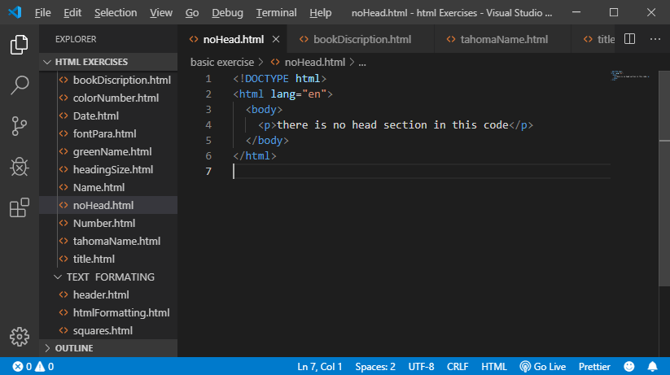

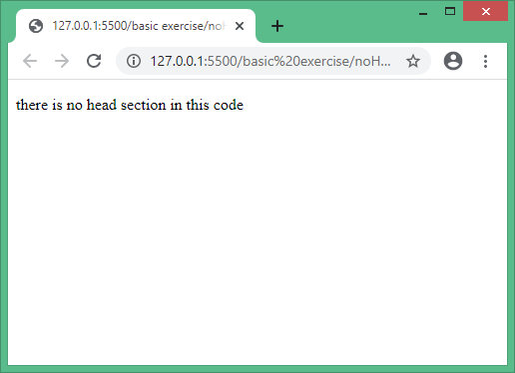

1. Printing name

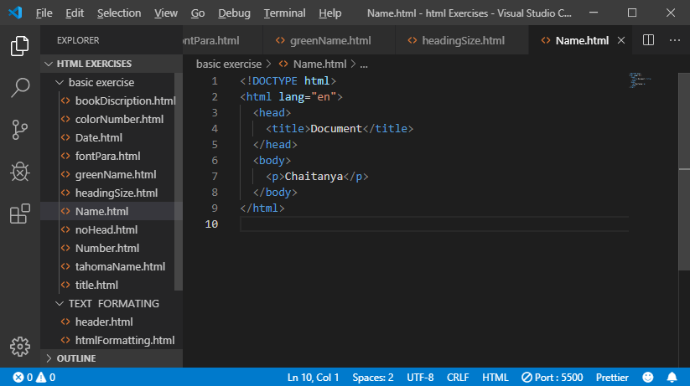

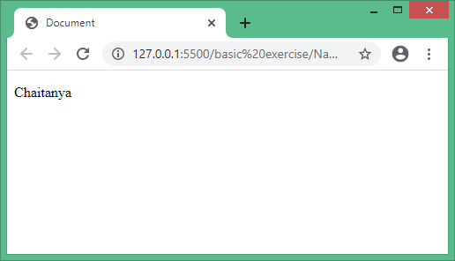

3.printing name in greeen color.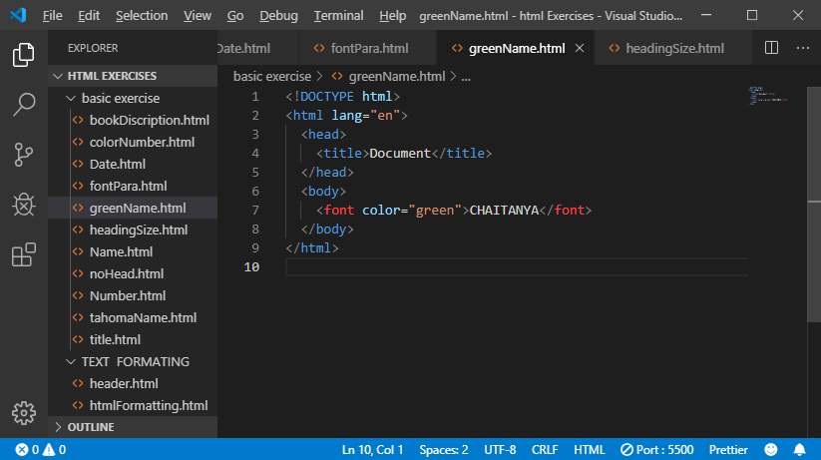

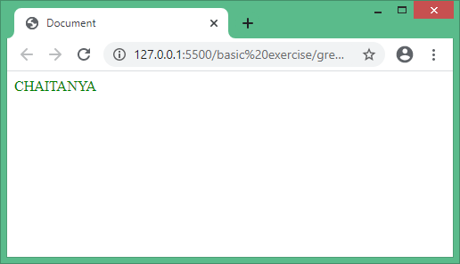

4. webpage that has title “this is a webpage”.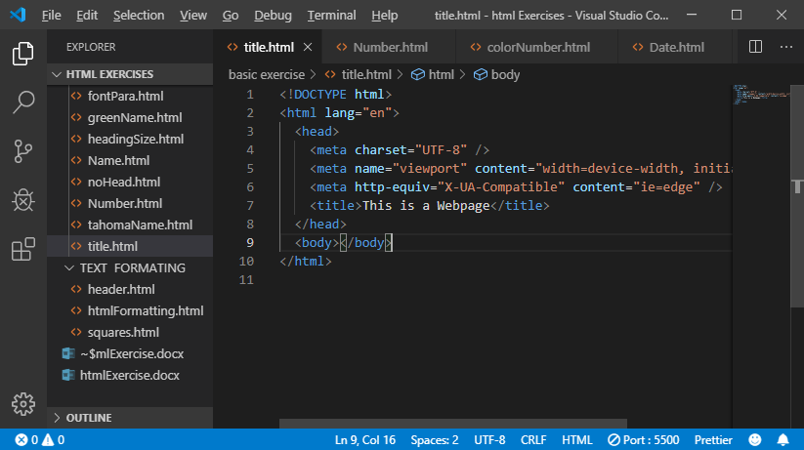

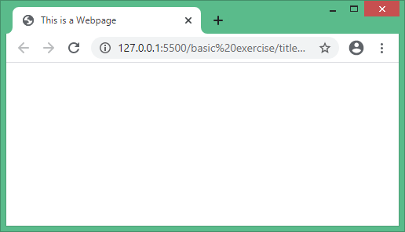

5. print name in tahoma font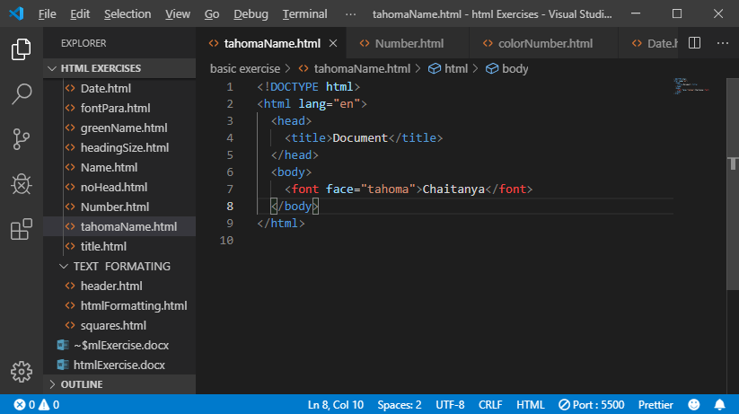

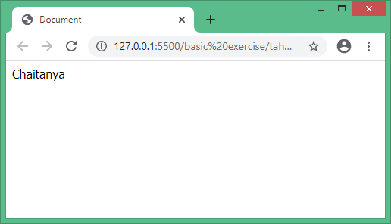

6. print book discription.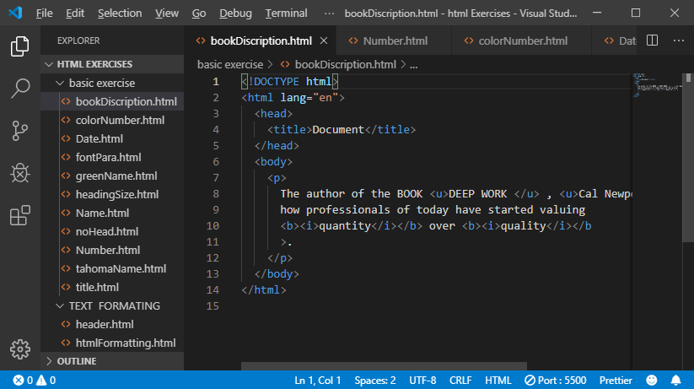

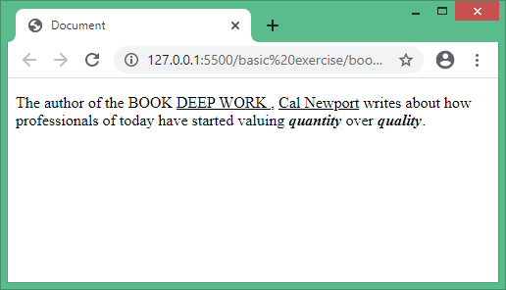

7. print numbers from 1 to 10.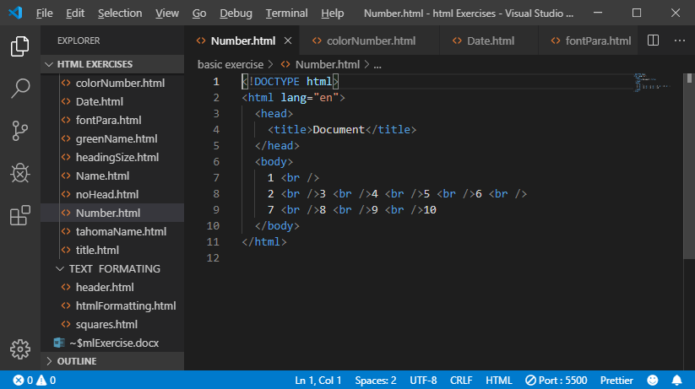

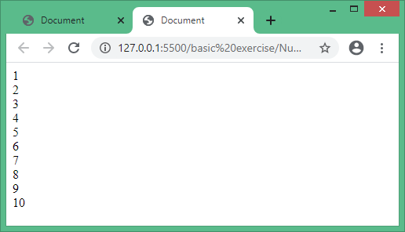

8. print nummbers with different colors.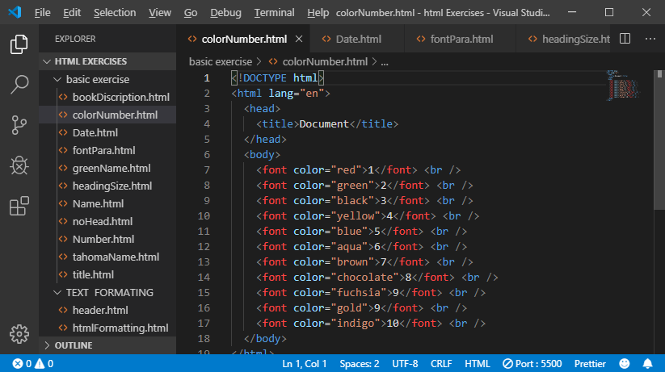

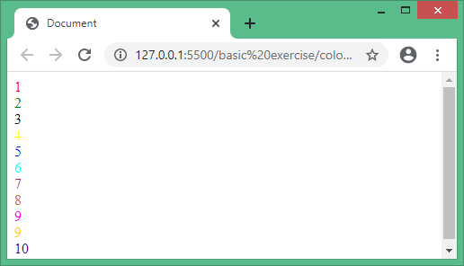

9. printing name with different heading size .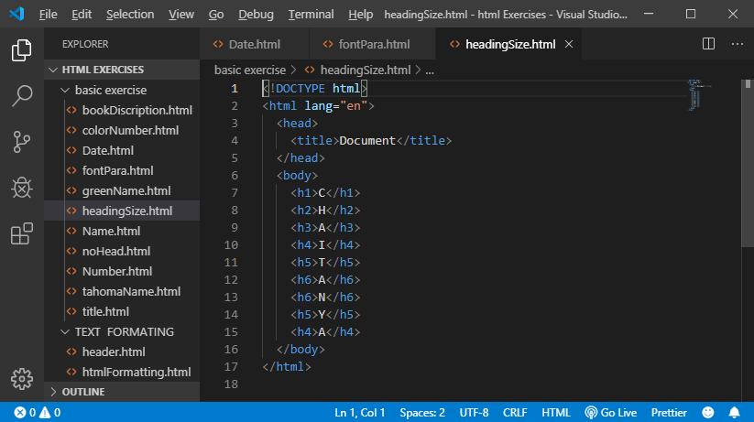

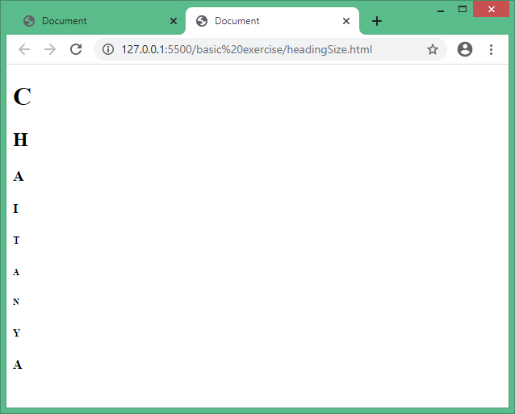

10.print paragraph with different fonts.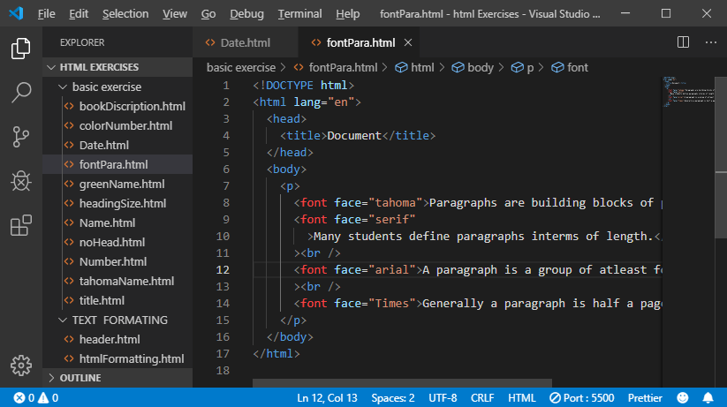

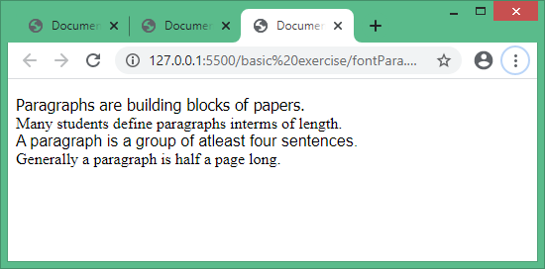

11.setting title as current date .

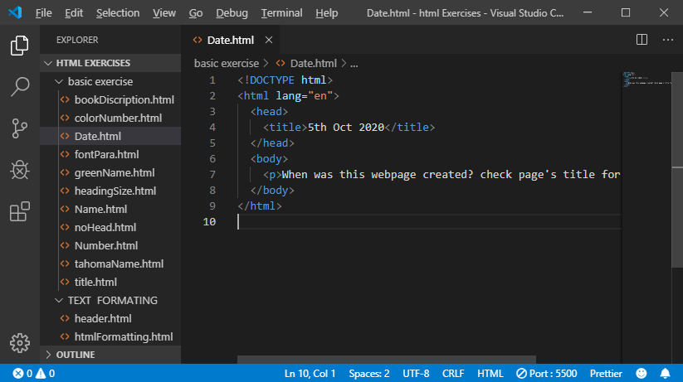

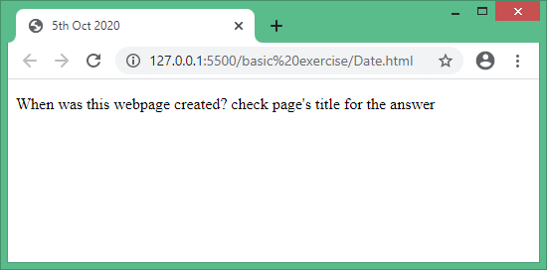

**TEXT FORMMATING**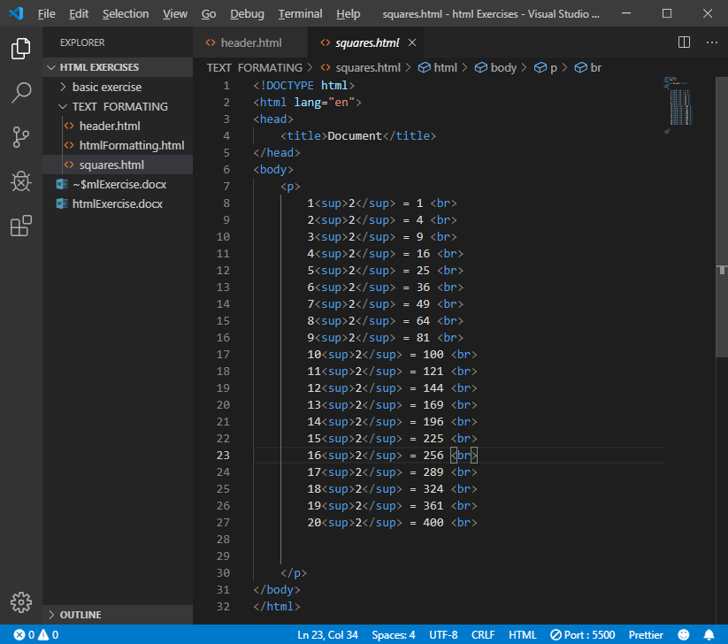

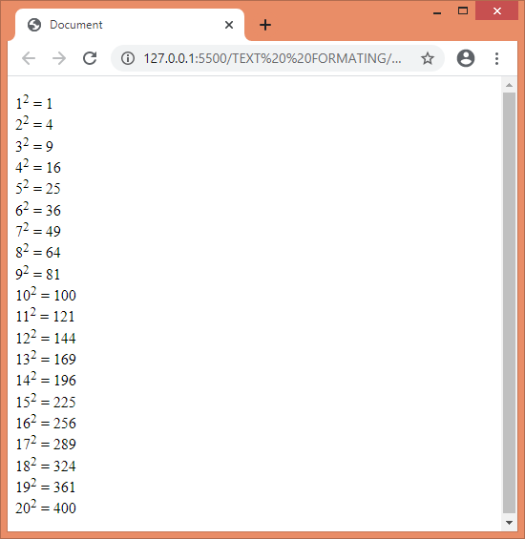

**Compilation of most html5 tags used for text formatting.**

<!DOCTYPE html>

<html lang="en">

<head>

    <title>Document</title>

</head>

<body>

    <header><h1>CO2CODE</h1></header>

    <nav>

        <ul>

            <a href="/index.html">home</a>

            <a href="/about us.html">about us</a>

            <a href="/about us.html">services</a>

            <a href="/about us.html">contact</a>

        </ul>

    </nav>

    <section>

    <address>Kannaikwada Morjim Pernem Goa</address>

    <article>

        Lorem ipsum dolor sit amet consectetur adipisicing elit.

        Porro ab aut, in consequatur ad maiores cum,

        quae culpa consectetur mollitia id amet velit,

        unde impedit eos quos. Vero, nobis ab.

    </article>

    <hr>

    <main id = 'demo content'>this is the main content

        which is displayed on the Document

        and the demo

    </main>

    <br>

    <aside id='demo content' >this is a para for the

        demo of the aside move of the

        main content

    </aside>

    </section>

    <section>

    <blockquote><cite> "quotation writing"</cite></blockquote>

    <dl>

        <dt>hello<dd>value(hello)=a way of greeting people</dd></dt>

    </dl>

    <figure>sample page</figure>

    <ol>

        <li>item 1</li>

        <li>item 2</li>

        <li>item 3</li>

    </ol>

    <ul>

        <li>item 1</li>

        <li>item 2</li>

        <li>item3</li>

    </ul>

    <p >

       <code>this is a paragraph</code>

        which represents 22 <b>text</b>

    </p>

    <data>

        <time>12:30</time>

    </data>

    <pre>

        the text will be displayed as it

        is in the html file

    </pre>

    <em>

    this is first level of the em

        <i>this is the second level</i>

    </em>

    <kbd>user input</kbd>

    <p>

      <sub>sample sub</sub>  this an example text <sup>sample sup</sup>

      <br>

      <strong>this is a strong text</strong>

      <br>

      <u>underlines the text</u>

      <br>

    </p>

    <abbr title="hyper text markup language">HTML abbrevation</abbr>

    <hr>

    <footer>  &copy; CO2CODE</footer>

    </section>

</body>

</html>

